Printer Installation and

Frequently Asked Questions

(MICR Printers, 2nd Edition)

Last Updated July 6, 2010

This document addresses the following printer models:

- Source Technologies ST-9612
- Source Technologies ST-9620
- Source Technologies ST-9630

****IMPORTANT NOTE ABOUT DRIVERS AND SETTINGS TO USE!****

- The only driver that works is on our download site, NOT on the disc with the printer.
- Default settings for the printer work great in Windows. No adjustments are needed.

The Source Technologies disk which ships with the printer contain only drivers meant to be used for normal office printing. Because MICR fonts are a secured resource, a special driver must be used.

The driver that works properly with the MICR fonts in your printer is named “Printer_Universal_UD0_Win_32_PCL_Emul.exe” and is available from the FamilyNet Download site: https://apps.state.or.us/familynet-app/. Look for the link called Download Universal Driver for ST-9612, 9620, and 9630 Printers. This is a “Universal Driver,” which means it works with all 32-bit Windows Operating Systems through Windows 7 and all three of the MICR models of printers.

Without this special driver, you will likely see multiple copies of the FI page printed, and an extra page containing a sequence of garbage characters known as “upsidedown T, smiley, degree, DIB.”

The default settings for the driver work for MICR applications like TWIST. You no longer need to make updates like you did in the past.

Table of Contents

How do I Install the Printer Driver? 2
How do I Enter a New FI Printer into TWIST? 8
I am using a network print queue. Where can I find the correct printer name for TWIST? (Doug needs to check this) 11
Why do other documents occasionally print on my FIs for no apparent reason? 12
Do I need to give my printers the exact same name on all my Windows workstations? 12
Which printer should I set to be the default on my workstation? 13
What is the “System Identifier”? 13
I cannot figure out why the printer is not being found. What can I do? 13
FI Alignment seems to be off. How can I fix that? 14
My printer won’t print and I have an error message or error light on the front panel of my printer. 15

How do I Install the Printer Driver?
A: To install the printer driver, follow these steps:

- At this point in the process, your printer should not be plugged into your computer. If it is a USB connection, Windows may attempt to locate the printer driver on its own before we’ve been able to provide the correct one with MICR support.
- Obtain the driver file from the FamilyNet download site, https://apps.state.or.us/familynet-app. Please note this is NOT the one on the disc that came with your printer. The link is called:
Download Universal Driver for ST-9612, 9620, and 9630 Printers

Save the file to a directory on your computer you can locate later, such as the desktop.
- The file will be called “Printer_Universal_UD0_Win_32_PCL_Emul.exe”. Open this file by double-clicking it, which will automatically extract the files to a temporary directory and run the program.
- Click the Agree button when the License Agreement appears.
- Accept the default when the destination dialog appears and click the Install button.
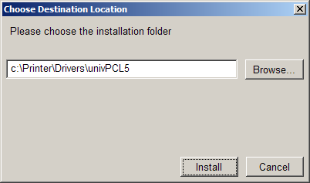
- Two windows will open after the second extraction. The upper left one shows the Printer Installation Wizard and the lower right one shows directions.
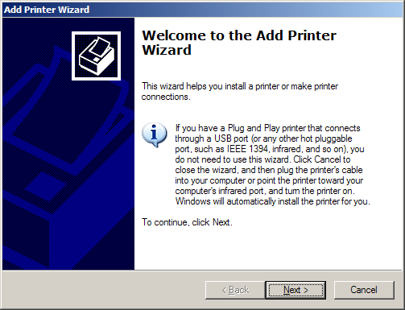
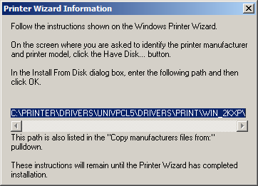
- Click Next.
- If this is a local printer (connected directly to the computer instead of being connected through the network), clear the checkbox option to “Automatically detect and install my Plug and Play printer,” as shown below. Click Next.
If this is a network, you will need the network address of the printer. Please consult your local Information Technology group for assistance.
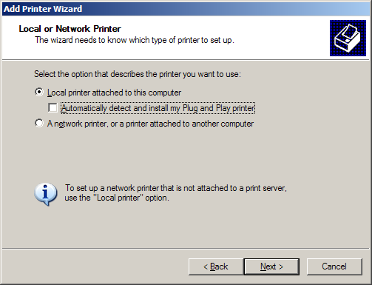

- Select the proper port for this printer.
If you are connecting the printer with a Parallel Cable, choose LPT1. A Parallel Cable is the one with this kind of connector:
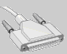
If you are connecting the printer with a USB Cable, choose USB.
Click Next.
- The next window allows you to choose the printer driver. At this point, click Have Disk…

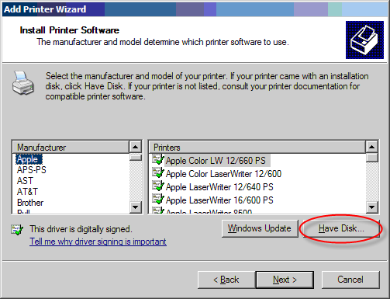
- The next dialog has a drop down which contains the default location where the files were extracted in the previous step. Select it and click OK.
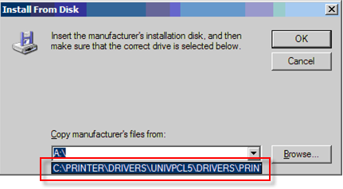

- The previous dialog will update to show the printer drivers in that directory. Scroll down the manufacturer list to “Source Technologies” and “Source Technologies” will appear under the Printers list.
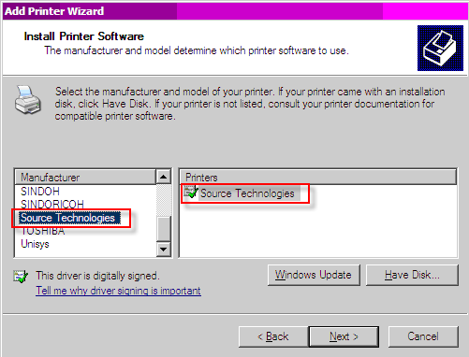
Click Next.

- If you get a “Use Existing Driver” dialog window asking you if you want to keep the existing driver or use the new one, select “Replace existing driver.”
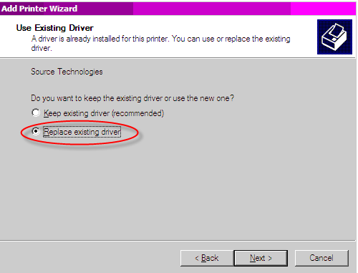

- Accept the default name of “Source Technologies” for the printer. If you alter the name, write it down for a later step. This is the name we need to give TWIST to be able to find the MICR printer.
Make sure that “No” is selected for the default printer question.

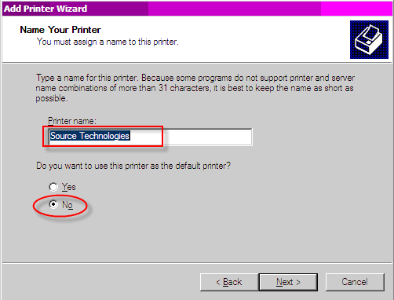
Click Next.
- Make sure that “Do not share this printer” is selected on the next screen and click Next.
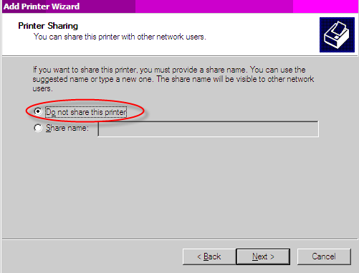
- Select “No” for the test page and click Next:

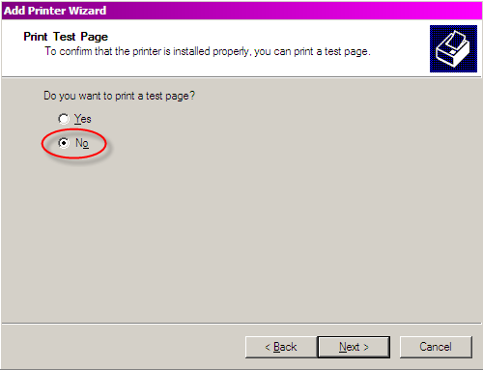

- Click Finish to complete the installation:

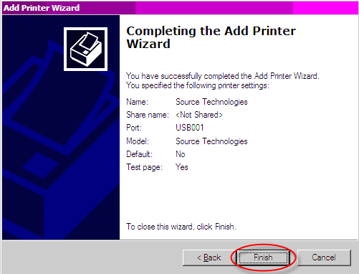

- After the installation is complete, plug in your printer and turn on the power.
- Click Start > Settings > Printers and Faxes.
- In some cases, a second printer will appear as “Source Technologies (Copy 1)” when Windows detects the printer again. If this occurs, follow these steps:
Delete the one you added by right-clicking it and choosing Delete.
Rename the copy by right-clicking the name and choosing Rename, then delete just the “(Copy 1)” portion from the end, including the space.
- Right-click on the “Source Technologies” printer or whatever you named it.
Choose Properties from the pop-up menu.
- Click the Print Test Page button on the General tab of the dialog box.

- You are now ready to enter the printer into the TWIST Food Instrument Printer list.

How do I Enter a New FI Printer into TWIST?
A: To enter the new printer into TWIST, follow these steps (see screen shots below):

- Log in to TWIST and go to Food Instruments > Tables > Food Instruments > Food Instrument Printers.

- Click on the + sign to enter a new record.

- Enter the printer name in the “Name” column. This name should be one easily identified by staff from a drop down menu. Clinic names or printer locations (e.g. “Front Desk”) are examples of useful names.

- Enter the system name for the printer in the “System Identifier” column. The name entered in this column must match the printer’s system name exactly.

- Enter the date for which the print should be available for use in the “Effective Date” column.

- NOTE: The “Type” column will default to “Source Tech” and cannot be changed.

- Click on the “Save” icon.

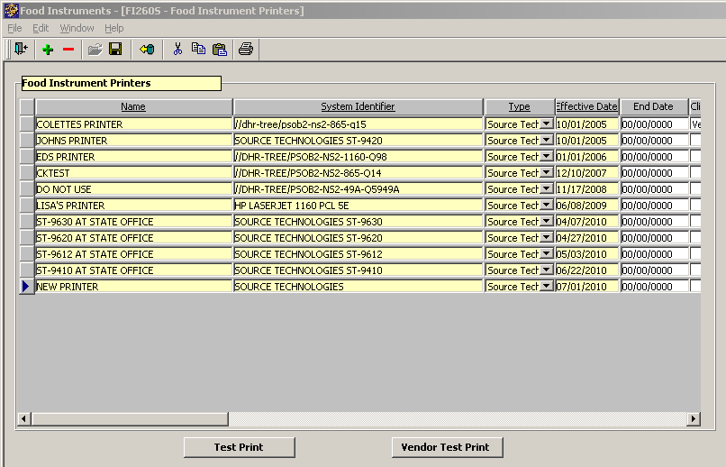

- You are now ready to print a test page from within TWIST. Click the “Test Print” button and select the new printer from the list.

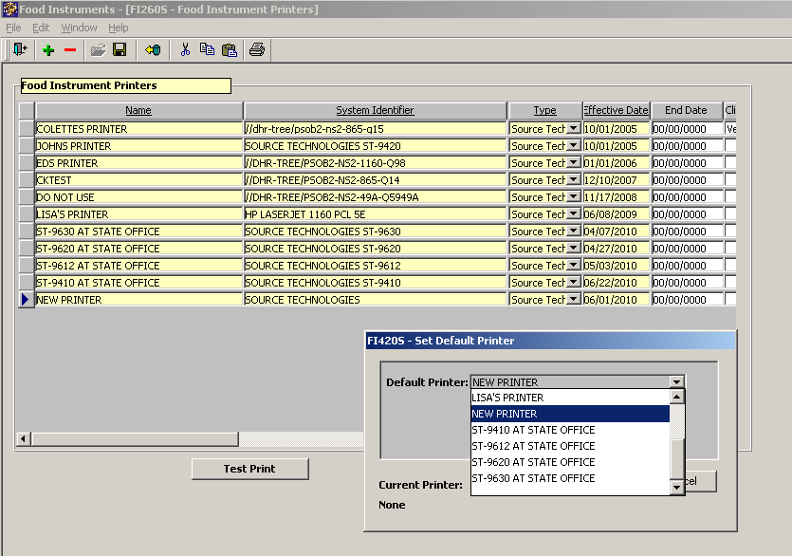

- Check the test print FI to make sure the alignment and MICR line are correct.

Checking alignment:
The position of the third FI on the page may vary, but the first two vouchers on the page should pass these visual tests (see image below):

- The words for the fields “First Day to Use” and “Last Day to Use” should be lined up perfectly with the top of the white box on the form (the text is just inside the box). These are not the dates themselves, but the words above the dates that should be flush with the top of the white box so that the top line of the “F” is right on the line.
- The labels “FI Type” and “Pay to the order of” should appear exactly halfway into their corresponding white boxes vertically, such that the top half of “FI Type” is blue and the bottom half is white.
- Each row of foods (the long string of X characters) should be snug against the white “Pay to the order of” and signature boxes.

A. Labels at very top of box
B. Top line halfway into box
C. Xs line up flush with box

Checking the MICR line:
Take a look at the MICR line to make sure the characters are correct. It should look like this:

If it doesn’t look like the above, but instead looks like the line below, call App Support to report the issue:

10. If the alignment and MICR line both look good, you are ready to print client vouchers.

I am using a network print queue. Where can I find the correct printer name for TWIST? (Doug needs to check this)
A: There are three options, of which the final one is best for people using Citrix to run FamilyNet.
Check the port on the Ports tab of the Printer’s properties. This will reveal the full System Identifier path. Please note that the column may need to be resized to see the full path.
Hold down the Control and Alt keys as you print test FIs and a special debugging window will come up. See the later question describing this feature.

In all cases, the trailing device information such as “,WINSPOOL,NE01:” is optional. In addition, you may specify more than one name to support a printer shared from a workstation that has both a network printer name and a local printer name. Separate the names with semi-colons.
Within Citrix, printer names get reformatted with a prefix showing the string “Client\machine_name#\” and then the name of the printer. You will not need to enter this prefix portion.

Why do other documents occasionally print on my FIs for no apparent reason?
A: The main reason that other documents print on FI stock is because the default printer on someone’s workstation is set to the MICR printer. The default printer should never be the FI printer; otherwise all sorts of documents will print to the FI printer (for example, if a user presses the Print toolbar button in MS Word it will print that document to the default printer.)
The user or network technician logs in and sets the default printer to the Laser printer for a given login, but as soon as someone else logs in it’s incorrectly set to the MICR printer again. Under certain network configurations, the printer default needs to be set for each login on each workstation. When a new user logs in to a workstation, it’s a good idea to verify that the default printer is set to something other than the MICR printer.

If you want to verify the default printer in Windows:
- Open the Printers folder by going to the Start menu, going to Settings, and selecting Printers
- The printer with the black ✓mark is the current default printer. If this is incorrectly set to the MICR printer, then right-click the Laser printer and select “Set As Default Printer”

Do I need to give my printers the exact same name on all my Windows workstations?
A: The TWIST software needs to know the name of the printer the user is using to print FIs. More than one name may be entered into the System Identifier field by separating them with semicolons, and this is especially useful for printers shared from a workstation. For example, the System Identifier might be:
Source Technologies;\\COUNTY12\Source Technologies
TWIST cycles through all of the printers defined on this workstation looking for the name in the System Identifier. It uses the first match it finds. To avoid entering a bunch of printer names, it is best to standardize on the fewest number of variations.
The printers are defined in the Food Instruments > Tables > Food Instruments > Food Instrument Printers window.

Which printer should I set to be the default on my workstation?
A: The Laser printer should be set to the default, not the MICR printer. Reports and certain other kinds of print jobs will print to the default printer (imagine a report printing on FIs!).

What is the “System Identifier”?
A: The System Identifier is a fancy name for the printer name as it appears in the Printers folder. Occasionally, it can also refer to a network print queue name (see other questions relating to choosing the workstation print queue versus the network print queue).
You may specify more than one System Identifier by separating them with semicolons. This supports a local printer name and a network printer name when one workstation in a set acts as the printer server by having the printer connected to it and sharing.
In TWIST, this is set in Food Instruments > Tables > Food Instruments > Food Instrument Printers.

I cannot figure out why the printer is not being found. What can I do?
A: FamilyNet includes an interactive debugging screen for troubleshooting FI printer problems as the printing occurs.
When you do the final step to print the FIs in TWIST, hold down the Control and Shift keys. A special runtime information screen will appear. This shows the system looking through all of the defined printers on the system for a match against the System Identifier list in TWIST. It may show a slight misspelling that prevents it from matching. When this window appears, the contents of it are also on the clipboard, making it possible to paste it into Notepad and pull out the printer name to save typing.
This happens to be an example for the old Lexmark printers, but the same thing applies to the MICR printers. The important thing is whether the Source Technologies printer in section 4 is properly spelled in section 1, which represents what is entered into the MICR FI printer table of TWIST.
(Image on next page…)
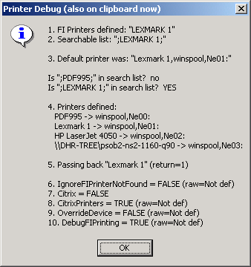

My printer won’t print and I have an error message or error light on the front panel of my printer.
A: Below is some information about the error messages on the LCD display for the ST-9620 and ST-9630 model printers:

Your Secure MICR Printer has a set of front panel error messages unique to MICR applications. These messages appear if there is a MICR related problem. The printer may also print an error message on the page near where the error occurred. In many cases you can receive more information about a displayed error by pressing Go to print the job which caused the error. Then inspect the printed page for a more detailed error message.

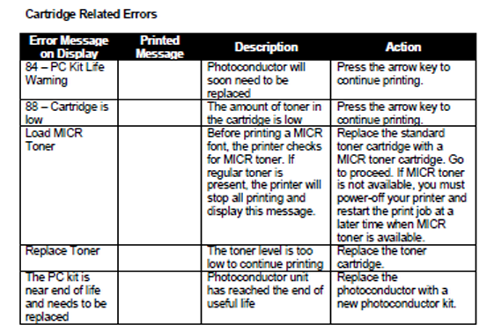

A: Below is some information about the error lights on the ST-9612 model printer:

Toner Cartridge and Photoconductor Units
The ST9612 MICR Print Cartridge is comprised of two components: the toner cartridge and the photoconductor unit. Toner cartridges are available in two models depending on the yield: a 1.5K page and a 3K page. The 1.5K model ships with new printers. The 3K model is the normal replacement model. The projected life in terms of page count is based on a typical 5% print coverage and continuous print mode. These projected values of 1,500 and 3,000 were certified using the ISO 19752 Yield Testing Methodology. The standard requires continuous print mode. The projected life is reduced somewhat dependent on the actual average print-job page count.

The photoconductor unit has a projected life in terms of page count of 20,000 to 30,000 dependent on average pages per print job. The 20,000 life is projected for 100% 1 page print jobs. The 25,000 life is projected for an average print job being at or near 3 pages. The photoconductor life for average print jobs being above 3 pages would exceed the
25,000 forecast.

The ST9612 MICR printer keeps record of the actual printing modes in terms of average print job size and the actual average print coverage percentage. The printer internally adjusts when either the toner cartridge or photoconductor unit needs to be replaced. The following error messages pertain to the toner and photoconductor unit:

Toner Low
The printer will stop with the Toner Low / Replace PC light and the Continue button ON steady. Press the Continue button and the printer will return to Ready and continue printing. The Toner Low light will remain ON, steady. While in the toner low state, the printer will stop again on power cycles and other operating situations such as jams or paper out conditions. Simply press the button to continue printing. The Toner Low light will remain ON until the cartridge is replaced or Toner Out is reached.

Toner Out
After approximately 300 pages beyond the first Toner Low condition the printer will stop printing and display the Toner Out condition. The Toner Low light will be ON steady and the Error light will blink. All other lights will be off. You must replace the toner cartridge to continue printing.

Photoconductor Unit Life Warning
As mentioned above, the printer internally calculates the average print-job size and actual average print coverage percentage. Once the photoconductor unit reaches approximately 85% of it usable life, the printer will stop with the Continue button ON. The Toner Low / Replace PC will be BLINK. Press Continue and the printer returns to Ready and printing will continue. This early warning is intended to provide a reasonable time for scheduling and obtaining a new unit for replacement.

When 100% of the usable life has been reached, the Menus Page will indicate the photoconductor life is “Exhausted”. The printer will still continue to print, but it is recommended the Photoconductor be replaced soon. The exposure for print quality related problems may be close due to printing beyond the projected usable life.

Replace Photoconductor (printer hard stop)
After the photoconductor unit exceeds 15% beyond the usable life point, the printer will hard stop with the Error and Toner Low / Replace PC lights BLINKING and the Continue button ON. If you press Continue, one page will print with instructions in multiple languages to replace the Photoconductor Unit referring to Appendix F.

Load MICR Toner
The Source Technologies’ Secure MICR Printer only supports MICR toner cartridges in its normal configuration. This prevents the printing of MICR documents with standard toner. If configured to support both MICR and standard cartridges, the PJL MICRJOB command checks the cartridge type and will prompt the operator with the following pattern to load MICR toner if not present.

